Importing the required libraries

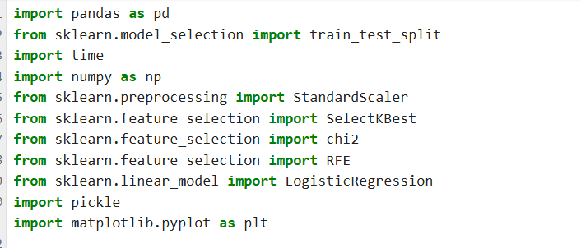

Function is created for Kbest

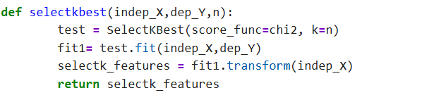

Indep_X 🡪 Independent Input

Dep_y 🡪 Dependent output

N 🡪 No of input(We can choose based on our wish)

Test =selectKBest(score_func=chi2, k=n)

Test 🡪 Variable, selectKBest 🡪 choosing K algorithm, chi2🡪 score to choose the best model, k=n no of parameter that we can choose.

Fit1=test.fit(indep_X,depY)

Fit1🡪 Variable, test.fit🡪 create model, indep_x and dep_Y 🡪 Input/output

select_feature🡪 Variable, fit1.transform(indep_X) 🡪 It will transform what are the best input that chosen based on the number we have given.

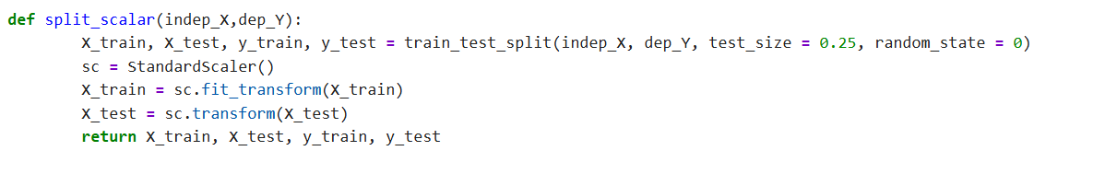

Scaler is used to preprocessing the values before goes into the model creation.

Split_Scalet(indep_X,dep_Y): 🡪 Function that to preprocess the input and output values

X-train,y_train,X_test,y_test 🡪 Separating traing and test set.

X_tran = sc.fit_transform(X_train) 🡪 Training data

X_test = sc.transform(X_test) 🡪 Test data

Return X_train, X_test, y_train, y_test 🡪 Return with train, and test data

Confusion Matrix:

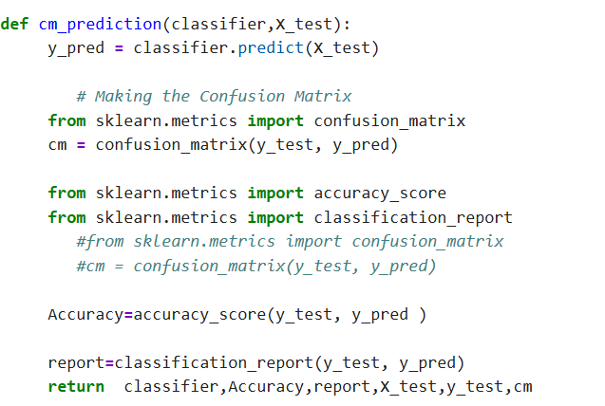

The above function create confusion matrix based on the given classifier and the Input.

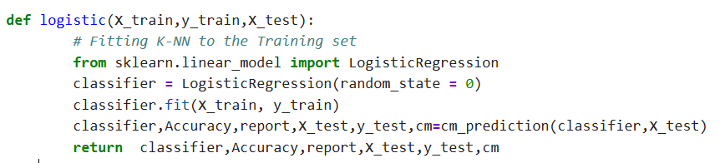

The above function creates the classifier model based on the logistic algorithm. It returns with model, accuracy, report, input, output, and confusion matrix.

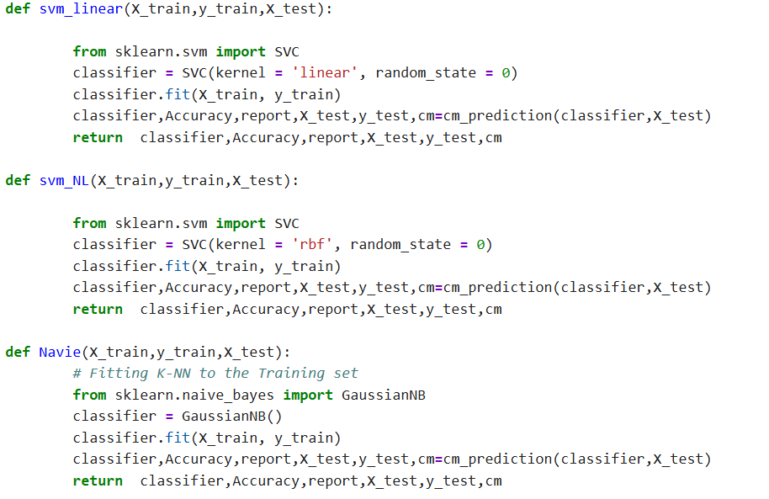

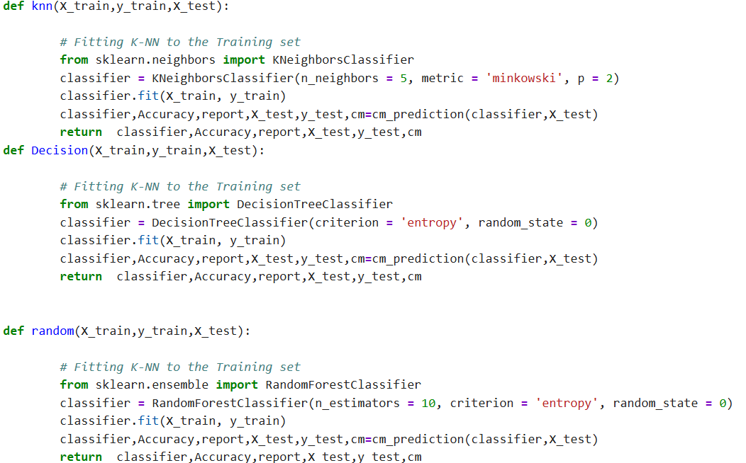

All the above algorithms creates models.

Creating a table:

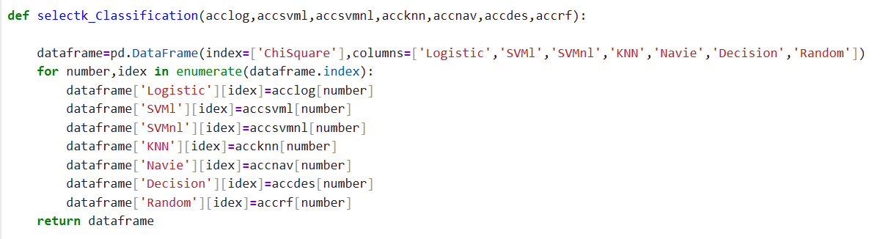

The above function creates a table with the model created .

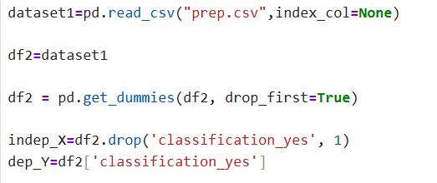

We run the csv file, the dataset1 is assigned to df2.

Categorical values are converted into onehot encoding by get dummies.

It creates independent input and dependent output.

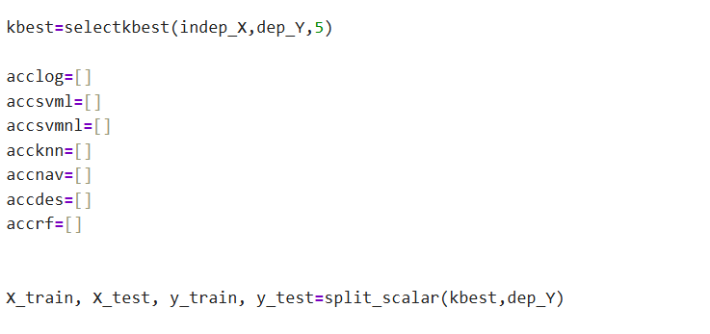

The accuracy of the each model will be saved in the command.

